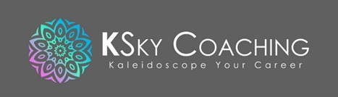
Goal Setting – Reflecting on 2022
Learn from yesterday, live for today, hope for tomorrow.

~ Albert Einstein
When planning for next year, it is important to look back on what happened and take the time to reflect, acknowledge, and learn from our experiences.
When you take a stroll through 2022, ask yourself:
- What were your 3 greatest achievements or favourite memories last year?
What went well? These don’t have to be big achievements like a promotion or a course certification, but even something like learning to cook or starting to read books again.
Some of us learn from other people’s mistakes and the rest of us have to be other people.
~ Zig Ziglar

- What did you learn – about yourself, your goals, motivations, life circumstances, opportunities, privilege, limitations, those around you…?
These can be positive or negative (i.e. what not to do) learnings.
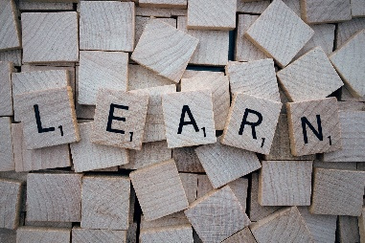
I never lose.

I either win or learn.
~ Nelson Mandela
- What would you have done differently?
In retrospect, were there actions that you now wished you had taken or had not taken?
What would you do if you had a rewind button to do things over? Keep this in mind for a similar situation in the future.
Ready to set your intentions for next year? Our Goal Setting worksheet can help: https://kskycoaching.com/worksheets-and-workbooks/

